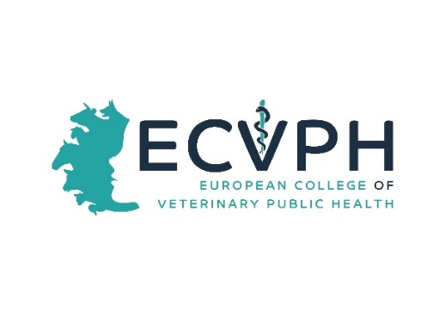

_________________________________________________________________

CALL FOR WORKSHOP PROPOSALS
Dear Colleagues,
For this Years´s Annual Scientific Conference and Annual General Meeting of the ECVPH which will be held in Perugia, 17-19. October 2018, we are organizing a Conference under the theme “Fading of the HACCP after four decades: new trends in VPH for food safety”. The Conference aims to feature three parallel workshops (2 hrs) on Thursday 18. October 2018 that are intended to once more provide a forum for researchers, policy makers and practitioners in Veterinary Public Health to discuss and exchange positions on current issues related to the this topic. Workshop attendants will exchange ideas and experience, establish common ground in research areas or practical problems. We would like to invite our Diplomates and the Residents to submit workshop proposals. This would be an opportunity to recognize expertise that we have within our College and hopefully identify new opportunities for collaboration and future activities. The workshop offered by the Diplomates and/or Residents that have been selected will be scheduled in the Conference program.
Submission format (please compile the form attached)
Workshop proposal must include:
- A concise title.
- The names and affiliations of the organizers
- A statement detailing: Why is the workshop topic important? Why is the workshop timely? How is it relevant to topic of the Conference?
- A two-paragraph description of the workshop topic and themes
- A short bio of the workshop organizers, including a description of their qualifications relative to the topic area
Important dates
- Workshop proposal submission deadline: extended to 23. April 2018 !
- Acceptance notification: April 30., 2018
- Workshop date: October 18th, 2018 from 13:30 to 15:30 (2 hours)
Please send your proposal described in the below form to: ecvphdocsec@gmail.com

Thanking in advance for your kind co-operation and looking forward to receiving your proposals,

with best regards,

Ed van Klink, ECVPH President

YOUR PROPOSAL
Title of Proposal

A concise title.
Contact Organizer
Salutation/title First name Surname

Affiliation (no abbreviations)

Email Phone

Address Line 1

Address Line 2

City and Postal Code Country

Please provide short bio of the workshop organizers, including a description of their qualifications relative to the topic area

Objectives
A statement of the objectives of the workshop and indication of its relevance, importance and timeliness

• A statement detailing: Why is the workshop topic important? Why is the workshop timely?

Description of the workshop topic and themes
Please provide a two paragraph description

